**DAILY ONLINE ACTIVITIES SUMMARY**

|  |  |  |  |  |  |  |  |
| --- | --- | --- | --- | --- | --- | --- | --- |
| **Date:** | **1/06/2020** | | | | **Name:** | **Ravi K R** | |
| **Sem & Sec** | **8th- B** | | | | **USN:** | **4AL16CS076** | |
| **Online Test Summary** | | | | | | | |
| **Subject** | | **SMS** | | | | | |
| **Max. Marks** | | **60** | | **Score** | | **60** | |
| **Certification Course Summary** | | | | | | | |
| **Course** | **Step into Robotic Process Automation successfully** | | | | | | |
| **platform** | | | **Ui Path** | **Duration** | | | **3 hours** |
| **Coding Challenges** | | | | | | | |
| **Problem Statement:** Given a string s consists of upper/lower-case alphabets and empty space characters ' ', return the length of last word (last word means the last appearing word if we loop from left to right) in the string.   1. If the last word does not exist, return 0.problem, assume that your function returns 0 when the reversed integer overflows.   You may assume that each input would have **exactly** one solution, and you may not use the same element twice. | | | | | | | |
| **Status: Executed** | | | | | | | |
| **Uploaded the report in Github** | | | | **Yes** | | | |
| **If yes Repository name** | | | | <https://github.com/alvas-education-foundation/Ravi_kr> | | | |
| **Uploaded the report in slack** | | | | **Yes** | | | |

Online Test Details:

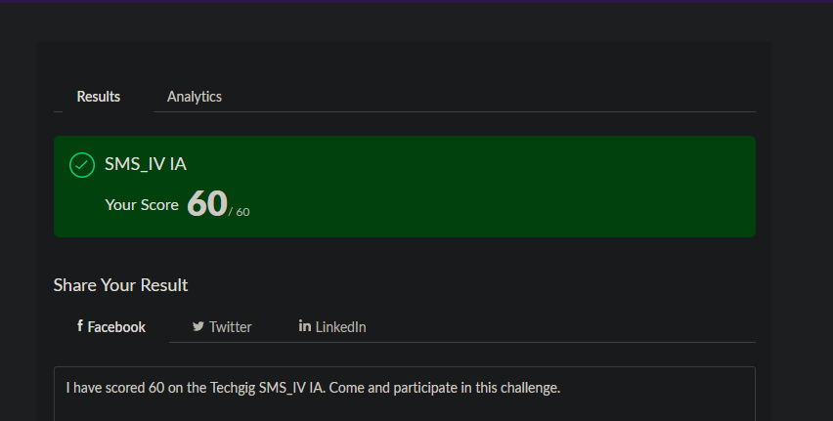

Certification:

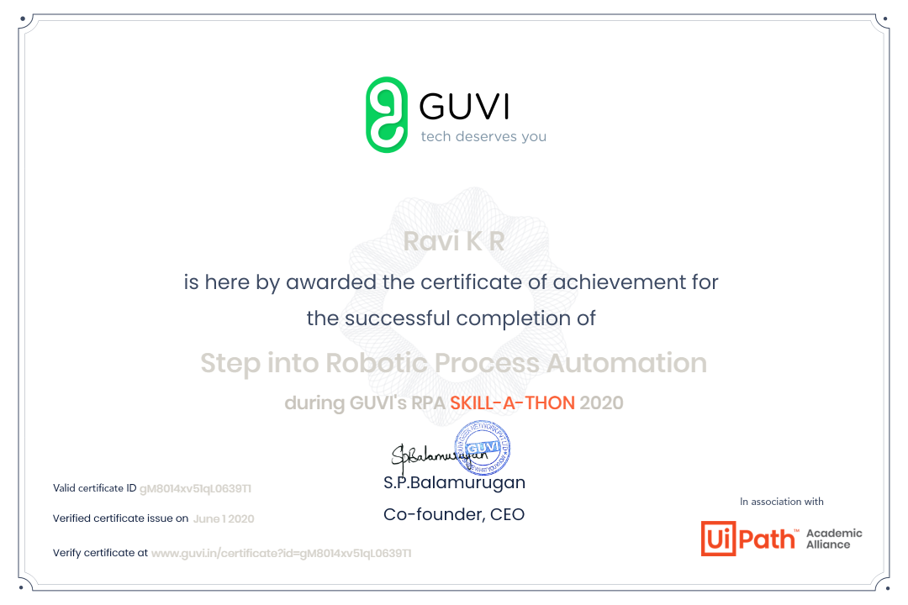

Coding Challenges Details: 